

BinGO
An application for waste management system

ITX3007 Software Engineering
Software Engineering term project
Instructor: Ass.Prof.Dr.Darun Kesrarat

Members:

Sai Lyeng Kham 6631013
Peerapong Chaichumpoo 6631014
Nyunt Tin 6632004

Contents

Topic and Scope of the system

Introduction
Effective waste management is a critical challenge in urban areas, impacting both environmental sustainability and public health. Traditional waste collection systems often suffer from inefficiencies, such as irregular pickup schedules, improper waste disposal, and high operational costs due to ineffective route planning. To address these issues, the BinGO application is designed as a mobile-based waste management solution that enables citizens to report filled bins and trash accumulation through image submissions. These reports are assisting waste management workers in optimizing collection routes and schedules. BinGO aims to enhance waste collection efficiency, reduce environmental pollution, and promote community engagement in maintaining a cleaner and healthier city.

Problem Statements
Current waste collection systems face several critical challenges:
- Inefficient Waste Collection Schedules: Waste pickup is often performed on fixed schedules rather than based on dynamic needs, leading to either overflowing bins or unnecessary trips.
- Improper Waste Disposal: Many citizens lack awareness of proper waste disposal methods, leading to environmental contamination and limited landfill space.
- Increased Operational Costs: Inefficient route planning results in excessive fuel consumption and labor costs.
- Limited Data for Route Optimization: Without real-time reports from citizens, waste collection agencies struggle to prioritize areas that need immediate attention.

Stakeholders
End users stakeholders: Citizens, Waste Management Workers, recycling center, IT staff, Application developer/designer, Third-party inspector

Objective
BinGO aims to:
- Provide a mobile platform for citizens to report full bins and areas with excessive waste.
- Assist waste management workers in optimizing pickup schedules and collection routes based on reported data.
- Educate users on proper waste disposal practices through in-app guides and tips.
- Reduce operational costs by eliminating unnecessary collection trips.
- Enhance environmental sustainability by promoting better waste management and increased recycling rates.

Project Goals
- Develop a user-friendly mobile application with an intuitive interface designed.
- Implement a mapping system that allows waste reports to be displayed to waste management authorities.
- Integrate notifications to alert waste collection teams about priority pickup locations.
- Encourage community engagement by allowing users to contribute to cleaner public spaces.
- Launch an initial test phase within the university before expanding to city-wide implementation.

Scope

Citizens
- Citizens can register their accounts using emails.
- Can log in with their personal accounts.
- Can submit image reports and messages to waste workers.
- Can find guides and tips on proper waste disposal in the app.
- Can contact the recycling center for information and support.
- Can track the status of their submitted reports.
- Receive notifications about waste pickup schedules and community clean-up events.

Waste Management Workers
- Can log in with their organization accounts.
- Can receive reports on filled bins and trash accumulation.
- Can view optimized collection routes to improve efficiency.
- Can update the status of waste collection tasks.
- Receive notifications and alerts on high-priority waste areas.
- Can communicate with citizens regarding waste collection concerns.
- Can generate reports on collection efficiency and operational challenges.
- Have access to a dashboard summarizing citywide waste reports.

Recycling Centers
- Can log in with their organization accounts.
- Can receive data on recyclable waste reports from citizens.
- Can list recycling guidelines for public awareness.
- Can notify citizens about recyclable waste collection schedules.
- Can coordinate with waste management workers for efficient waste sorting.

Administrator
- Can log in with an administrator account.
- Can oversee the overall application system and user management.
- Can manage and approve citizen-submitted waste reports.
- Can update the waste management schedule and optimize system workflows.
- Can analyze system data for insights on waste trends.
- Can ensure smooth communication between all stakeholders.
- Can generate and export reports for city officials and stakeholders.
- Can implement new features and updates based on feedback.

DFD Diagram

ER Diagram of the system

Data Dictionary

Citizens

Column | Type | Null | Description | Example
citizen_id(PK) | int | no | Unique citizen ID | 156551354
name | varchar(50) | no | Citizen’s name | John Cena
email | varchar(100) | no | Citizen’s email | John_Cena@email.com
password | varchar(20) | no | Citizen’s password | iaminvisibleman001

Waste report

Column | Type | Null | Description | Example
report_id(PK) | int | no | Unique report ID | 10001
citizen_id(FK) | int | no | ID of the citizen who submitted | 156551354
image | varchar(255) | no | Image file path | /uploads/bingo1.jpg
location | varchar(100) | no | Reported bin location | 201/760 Bangbo Samutprakarn
status | varchar(20) | no | Report status(Pending,resolved) | Pending
Waste Management Worker

Column | Type | Null | Description | Example
worker_id(PK) | int | no | Unique worker ID | 3100
name | varchar(50) | no | Worker’s name | Michael Jacks
email | varchar(100) | no | Worker’s email | oohh_mj@wasted.com
password | varchar(20) | no | Worker’s password | smoothfeet1234

Recycling Center

Column | Type | Null | Description | Example
center_id(PK) | int | no | Unique center ID | 4101
name | carchar(50) | no | Center’s name | Bangbo Green day
location | varchar(100) | no | Center’s address | 89/123 Bangbo Bangnatrad Street
contact_email | varchar(100) | no | Contact email | BBGreend@email.com
phone | carchar(15) | no | Contact phone number | +66 521475621

Notification

Column | Type | Null | Description | Example
notification_id  (PK) | int | no | Unique notification ID | 5111
user_id(FK) | int | no | The recipient user’s ID(citizens,workers,centers) | 1100
message | text | no | The content of notification | “Your bin has been collected.”
type | varchar(20) | no | Notification type(Alert,Reminder) | “Reminder”
status | varchar(20) | no | Read/Unread status | “Unread”
timestamp | datetime | no | Time the notification was sent | 2025-02-01  18:30:00

Admin Table

Column | Type | Null | Description | Example
admin_id(PK) | int | no | Unique admin ID | 9855
name | varchar(50) | no | Admin’s name | Clint westwood
email | varchar(100) | no | Admin’s email | Clint_West@bingo.com
password | varchar(20) | no | Admin’s password | Cw985514031869
Project Prototype (User Interface)

Project Management

Methodology
For BinGO, we chose the Agile methodology, specifically Scrum, because it allows us to develop the application in iterations while continuously improving based on feedback. Since the project involves multiple stakeholders—citizens, waste workers, recycling centers, and administrators—we needed a flexible approach that ensures quick adaptation to their needs.
By following Scrum, we broke the project into sprints (short development cycles of 2-4 weeks), where we focused on building, testing, and refining features. This helped us avoid long delays and ensured that we delivered a functional product at each stage.

Project Development Steps (Scrum-Based Agile Process)

1. Project Planning
- We began by defining the problem, objectives, and target stakeholders.
- We created an initial prototype using Figma to visualize the user interface and core functionalities.
- We identified key features such as image reporting, waste worker dashboard, and notifications.

2. Requirement Analysis
- We conducted research on waste management issues and how technology could improve efficiency.
- We gathered input from potential users (students, faculty, and city waste workers) to refine our concept.
- We compiled a list of functional and non-functional requirements for the system.
3. Prototype Development
- Using our research and requirements, we designed a mobile application prototype.
- The prototype included features such as user registration, image submission, and a map-based reporting system.
- We refined the UI/UX to ensure usability and accessibility.
4. Sprint Planning
- We divided the development process into several sprints, focusing on different aspects of the system:
  - Sprint 1: User authentication and account management.
  - Sprint 2: Image submission and waste report tracking.
  - Sprint 3: Map integration for waste worker visualization.
  - Sprint 4: Notifications and system optimization.
- Each sprint included design, feedback, and revisions.
5. Sprint Review
- At the end of each sprint, we demonstrated the updated prototype to our project advisor and classmates.
- We collected feedback on usability, feature relevance, and improvements.
- This feedback helped refine the design and prioritize changes for the next sprint.
6. Sprint Retrospective
- After each sprint review, we reflected on what worked well and what could be improved.
- We adjusted our approach based on insights from testing and feedback.
- For example, early feedback suggested adding a waste disposal guide, which we incorporated into later iterations.
7. Iteration
- We repeated steps 2-6 for multiple sprints, continuously refining our prototype.
- This iterative process allowed us to adapt the system design to evolving insights and requirements.
- We simulated various scenarios to validate system functionality.
8. Project Finalization
- After several sprints, we finalized our prototype with all core features.
- We conducted a final round of comprehensive testing to ensure that the system met its intended objectives.

Development Tools
- Integrated Development Environment (IDE)
  - IntelliJ IDEA: A powerful IDE with excellent support for JavaScript and Node.js, ideal for full-stack development.
- Version Control
  - Git: Distributed version control system for tracking code changes.
  - GitLab: Repository hosting and CI/CD pipeline integration for seamless collaboration.
- Frontend Development
  - React Native: Framework for building cross-platform mobile applications with a single codebase.
- Backend Development
  - Django: Python-based framework for robust backend development and API creation.
- Database Management
  - Firebase: Real-time database for quick prototyping and user data management.
- Cloud Services
  - MongoDB Atlas (M10) : for cloud services
- Authentication
  - Firebase Authentication: Simple and secure authentication system for user management.
- Project Management and Collaboration
  - Microsoft Teams: Communication platform for team meetings and discussions.
- UI/UX Design
  - Figma: Collaborative interface design tool for creating and prototyping user interfaces.
10. Testing
Unit Testing: Jest (for React Native and Node.js).
Integration Testing: Supertest (for APIs) + Firebase Emulator Suite (for Firebase integration).
E2E Testing: Detox (for React Native mobile app).
UI/UX Testing: Storybook (for React components) + Figma Prototyping.
Performance Testing: Lighthouse (for web) + k6 (for API load testing).
Security Testing: OWASP ZAP + Firebase Security Rules Testing.
Accessibility Testing: axe (for web and mobile accessibility).
CI/CD Testing: GitHub Actions (for automated testing and deployment).

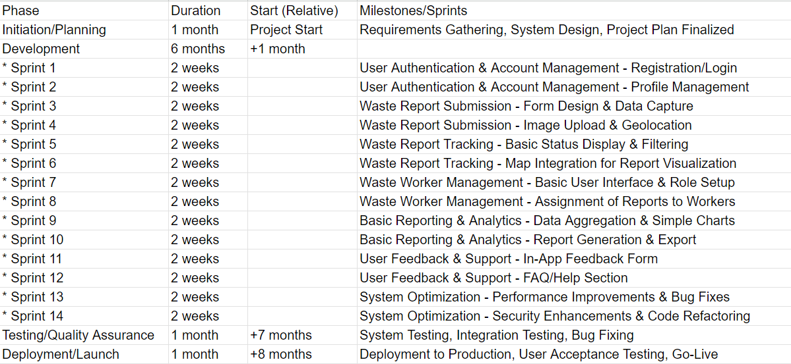
Project Timeline

Cost Analysis
Estimated LOC: ~10,000 lines (10 KLOC).

Effort Calculation
- KLoc (Thousands of Lines of Code) = 10
- Formula: E = 2.4 × (KLoc)^1.05
- Calculation: E = 2.4 × (10)^1.05 = 26.49 person-months
Development Time Calculation
- Formula: D = 2.5 × (E)^0.38
- Calculation: D = 2.5 × (26.49)^0.38 = 8.33 months (rounded to 9 months for practical purposes).
Number of People Required
- Formula: N = E / D
- Calculation: N = 26.49 / 8.33 ≈ 3 persons
Cost Breakdown
1. Development Period
- Duration: 9 months
2. Employee (Developers) Cost
- Junior Developer: 35,000 baht/month
- Mid-level Developer: 50,000 baht/month
- Senior Developer: 70,000 baht/month
- Total per Month: 35,000 + 50,000 + 70,000 = 155,000 baht/month
- Total for 9 Months: 155,000 × 9 = 1,395,000 baht
3. Cloud Services
- MongoDB Atlas (M10 Dedicated Cluster): 8,500 baht/month × 9 months = 76,500 baht
4. Development Tools
- GitHub Team Plan: 1,500 baht/month × 9 months = 13,500 baht
- Jira Software: 2,500 baht/month × 9 months = 22,500 baht
5. Miscellaneous (Software Licenses, Testing Devices, etc.)
- Estimated Cost: 50,000 baht

Total Estimated Cost
Item | Cost | Note
Employee Cost | 1,395,000 THB | 3 Developers
*Junior Developer | (included) | 35,000 THB/Month
*Mid-level Developer | (included) | 50,000 THB/Month
*Senior Developer | (included) | 70,000 THB/Month
Cloud Service | 76,500 | MongoDB Atlas (M10)
Development Tools | 36,000 | GitHub Team Plan & Jira Software
* GitHub Team Plan | (Included) | 1,500 THB/month
* Jira Software | (Included) | 2,500 THB/month
Miscellaneous | 50,000 | Licenses, Testing Devices, etc.

Total Estimated Cost 1,557,500 THB

Benefits Analysis for BinGO Application
- Our system is expected to enhance the efficiency of waste collection and management within the community.
- With users being able to easily report waste issues (overflowing bins, illegal dumping, etc.) the process of addressing these problems is expected to be streamlined and more effective.
- Waste management authorities will have more accurate and timely information about waste issues, allowing them to allocate resources more efficiently and respond more quickly.
- The number of unreported or delayed waste issues is expected to decrease effectively, as citizens will have a convenient way to report problems.
- The reporting feature allows for better communication between citizens and waste management authorities, potentially increasing community engagement and improving overall service.
- The tracking system enables users to monitor the status of their reported issues, increasing transparency and accountability.
- With a dedicated platform for waste management reporting and tracking, the overall cleanliness and sanitation of the community are expected to improve.

- The app provides valuable data on waste generation patterns, hotspots, and trends, which can help authorities to better understand waste management needs and optimize long-term planning.
- By enabling citizens to easily report issues and track their resolution, we expect to foster a greater sense of community responsibility and encourage active participation in waste management.

